A Long Way Gone: Chps 2-3 Dialectical Journal
Directions: Write FIVE entries (total) based on chps 2-3. Make sure your responses are detailed and insightful.

Key:
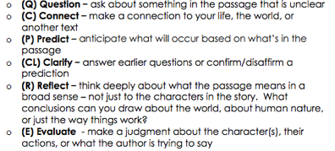

Cited Passage from the Text | Response
Example:  “The image of the woman and her baby plagued my mind as we walked back to Mattru Jong” (14). | Example:  Beah’s description of being “plagued” by the image of the woman and her baby reminds me of the photo I saw of the lifeless body of a young Syrian boy, a refugee, washed up on a beach. It’s another example of the impact of war and conflict on children, and it’s hard to forget. (C, R)

Cited Passage from the Text | Response

