Gilgamesh Project
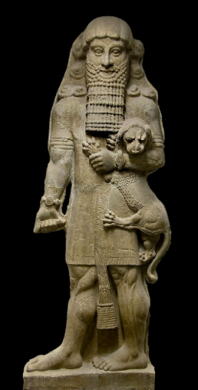
Overview: In groups of no more than three, you will create a presentation regarding Gilgamesh to present to the class.

Option 1: Create a Google Slideshow (Prezi for extra credit) or a poster where you compare and contrast the flood stories from Gilgamesh and the Bible.

Group Members’ Names:____________________________________________________
Rubric:
Basic Requirements:  Slideshow/poster must include the following:  -Title and group members’ names  -Overview of flood story in Gilgamesh  -Overview of flood story from the Bible  -Similarities (include at least two quotes and citations)  -Differences (include at least two quotes and citations)  -Conclusion based on similarities/differences (what do your findings suggest about the flood, the cultures, etc.?)  -Illustrations/images related to topic  -Information should be accurate and demonstrate an understanding of the text(s). | Teachers’ Comments: | ____/16
Grammar/Spelling/Neatness:  Slideshow/poster must:  - be neat, demonstrate effort  - be free of spelling & capitalization errors  - have appropriate punctuation (including how quotes are cited). |  | ____/9
Presentation:  -All group members must speak  -Presentation must be polished (should be obvious that you’ve practiced)  -Body language should be appropriate/professional  -Eye contact should be made |  | ____/8
**Bonus for Prezi +5 | Total: | _____/33

Option 2: Create a Google Slideshow (Prezi for extra credit) or a poster where you compare and contrast the heroic journey of Gilgamesh to a heroic journey found in another book or movie.

Group Members’ Names:____________________________________________________
Rubric:
Basic Requirements:  Slideshow/poster must include the following:  -Title  -Overview of heroic journey in Gilgamesh  -Overview of heroic journey in chosen movie/book  -Similarities (include at least two quotes and citations)  -Differences (include at least two quotes and citations)  -Conclusion based on similarities/differences (what do your findings suggest about the heroic journey?)  -Illustrations/images related to topic  -Information should be accurate and demonstrate an understanding of Gilgamesh. | Teachers’ Comments: | ____/16
Grammar/Spelling/Neatness:  Slideshow/poster must:  - be neat, demonstrate effort  - be free of spelling & capitalization errors  - have appropriate punctuation (including how quotes are cited). |  | ____/9
Presentation:  -All group members must speak  -Presentation must be polished (should be obvious that you’ve practiced)  -Body language should be appropriate  -Eye contact should be made |  | ____/8
**Bonus for Prezi +5 | Total: | _____/33

Timeline:
Monday | Tuesday/Wed | Thurs | Friday
10/28  X | 10/29 or 10/30  -Intro to project  -Form groups  -Choose topic  -Brainstorm/begin research  -Gather info for background/overview | 10/31  (half of period)  -Finalize background/overview info  -List similarities and differences  (checked at end of period) | 11/1  -Find quotes  -Draw conclusion  (checked at end of period)
11/4  -Finalize and practice presentation | 11/5 or 11/6  -Present and submit slideshow or poster

