Truth Be Told...
Writing Project: A Long Way Gone

On page 199, Ishmael shares what he’s experienced in Sierra Leone and what he learned from those experiences with the UN Economic and Social Council. He said:
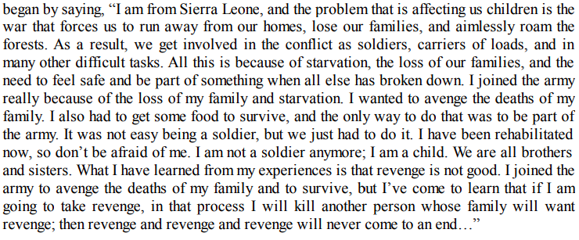

Project Requirements:
I. For this assignment, you will write about and share a “truth” that you have learned though experience. You will be required to share the background of the situation, how you learned the lesson, and what the lesson is (it should apply to all people, not just you). Some topics you might consider include the truth about:
- Family  - Friends  - Education | - Plans  - Relationships  - Health | - Politics/Government  - Money  - Emotions
*Note: You are not limited to the topics listed above.

II. Choose one of the three formats:
*Speech *Poem *Song/Rap

III. Complete the assignment based on the requirements in the rubric below.
Requirements | Score
*Speech: Must be at least two paragraphs in length (minimum six sentences per paragraph). Sentence variety is required (simple, compound, complex, etc.).  *Poem: Must be at least 20 lines in length.  *Song: Must be at least 20 lines in length. | 0 – 5 – 10 – 20
All:  Writing  *Speech/poem/song must be typed or neatly written in blue or black ink.  *Must have a title.  *Must make sense and include background information about the situation you learned from, how your learned your lesson, and ultimately what you learned (as it applies to all people).  *Must be free of grammatical, spelling, and capitalization errors. | 0 – 5 – 10
All:  Presentation  *Speech, poem, or song must be presented to the class.  *Presentation should be polished and professional (body language/attitude should be appropriate)  *Eye contact should be made  *Voice should be easily heard | 0 – 5 – 10
Bonus Points:  *Memorized poem/song  *Speech presented with just notes on a notecard (not whole speech written out)  *Other (see me with ideas) | +5
Total: | ____/40
*Note: Please be aware that I have to report any mention of abuse or suicidal thoughts to the counselors.

